Week 7 Time Series Data Analysis
##Read Data
Data_IBM_monthly <- read.csv("C:/Users/Pradeep Singh/Documents/Professional/CSDA5110/Fall_2024/Week7/Ch2_Data_IBM_monthly.txt", sep="")
View(Data_IBM_monthly)
head(Data_IBM_monthly)
## date ibmrtn vwrtn ewrtn sprtn
## 1 19260130 -0.010381 0.000724 0.023174 0.022472
## 2 19260227 -0.024476 -0.033374 -0.053510 -0.043956
## 3 19260331 -0.115591 -0.064341 -0.096824 -0.059113
## 4 19260430 0.089783 0.038358 0.032946 0.022688
## 5 19260528 0.036932 0.012172 0.001035 0.007679
## 6 19260630 0.068493 0.056888 0.050487 0.043184
sibm=Data_IBM_monthly [ ,2]
vw=Data_IBM_monthly [ ,3]
libm = log(sibm+1)

Time Series plot
s1=ts(sibm, frequency=12, start =c(1926,1))
plot(s1)
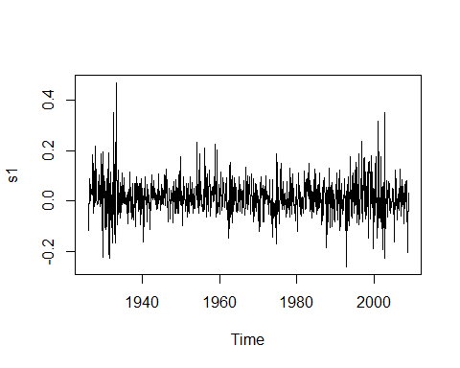
s2=ts(libm, frequency=12, start =c(1926,1))
plot(s2)
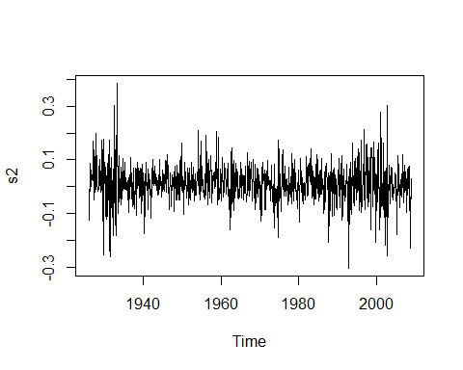
s3=ts(vw, frequency=12, start =c(1926,1))
plot(s3)
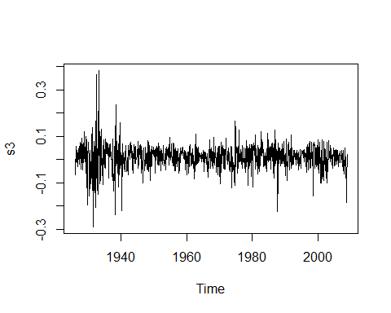 ## ACF plot
acf(s1, lag=24)
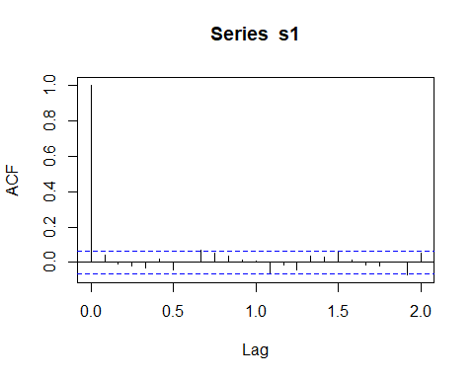
acf(s2, lag=24)
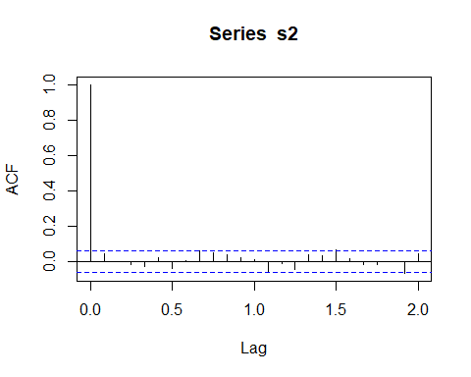
acf(s3, lag=24)
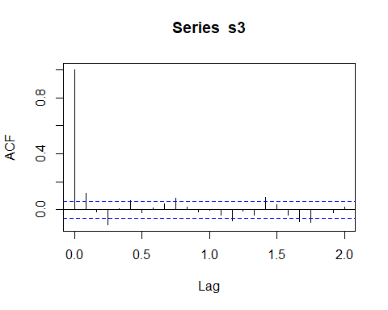 ##plot without timwseries object
plot(sibm)
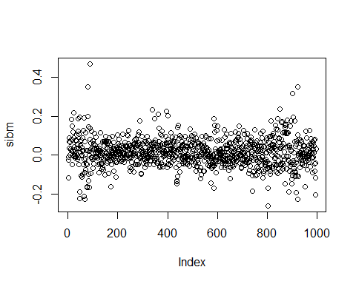
plot(libm)
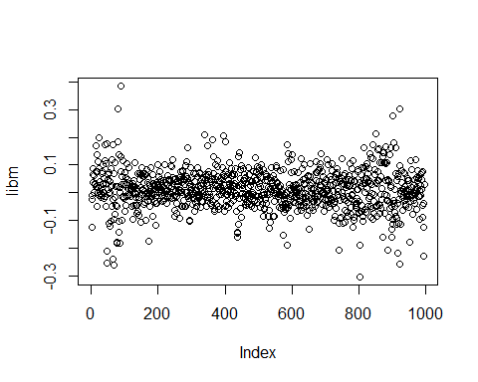
plot(vw)
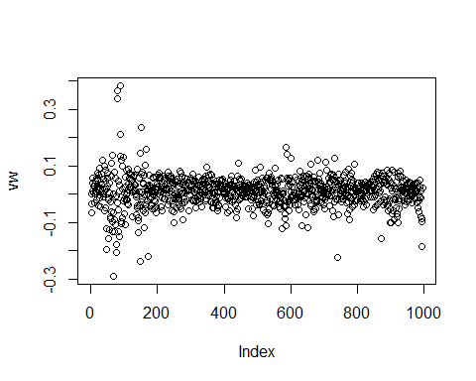 ## fit model
library(forecast)
## Registered S3 method overwritten by 'quantmod':
## method from
## as.zoo.data.frame zoo
m1 <- auto.arima(x=sibm)
m1
## Series:
## ARIMA(2,0,2) with non-zero mean
##
## Coefficients:
## ar1 ar2 ma1 ma2 mean
## -0.5642 -0.9091 0.5886 0.9402 0.0133
## s.e. 0.2894 0.2065 0.2351 0.1969 0.0023
##
## sigma^2 = 0.005094: log likelihood = 1218.47
## AIC=-2424.93 AICc=-2424.85 BIC=-2395.51
m2 <- auto.arima(x=libm)
m2
## Series:
## ARIMA(0,0,0) with non-zero mean
##
## Coefficients:
## mean
## 0.0109
## s.e. 0.0022
##
## sigma^2 = 0.004947: log likelihood = 1231.13
## AIC=-2458.26 AICc=-2458.25 BIC=-2448.45
m3 <- auto.arima(x=vw)
m3
## Series:
## ARIMA(2,0,2) with non-zero mean
##
## Coefficients:
## ar1 ar2 ma1 ma2 mean
## -0.1679 -0.6572 0.3026 0.6968 0.0089
## s.e. 0.2029 0.0875 0.1983 0.0823 0.0019
##
## sigma^2 = 0.002868: log likelihood = 1504.51
## AIC=-2997.02 AICc=-2996.93 BIC=-2967.6

Residual Analysis
If model fit is good then ACF plots should be white noise (no autocorrelation)
acf(m1$residuals)
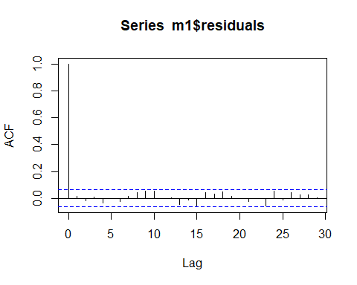
acf(m2$residuals)
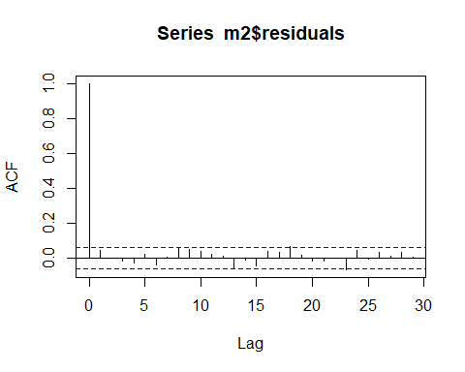
acf(m3$residuals)
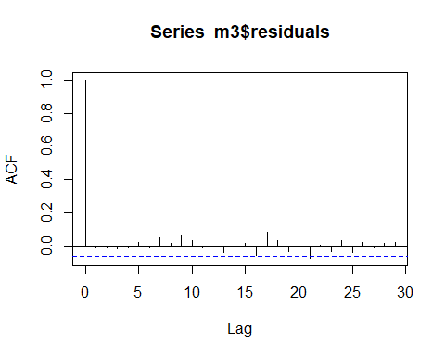

Prediction
predict(m1, n.ahead=5, se.fit=TRUE)
## $pred
## Time Series:
## Start = 997
## End = 1001
## Frequency = 1
## [1] 0.020831643 0.013375687 0.006502519 0.017158161 0.017394419
##
## $se
## Time Series:
## Start = 997
## End = 1001
## Frequency = 1
## [1] 0.07137278 0.07139407 0.07140481 0.07144132 0.07144150
predict(m2, n.ahead=5, se.fit=TRUE)
## $pred
## Time Series:
## Start = 997
## End = 1001
## Frequency = 1
## [1] 0.01089135 0.01089135 0.01089135 0.01089135 0.01089135
##
## $se
## Time Series:
## Start = 997
## End = 1001
## Frequency = 1
## [1] 0.07033329 0.07033329 0.07033329 0.07033329 0.07033329
predict(m3, n.ahead=5, se.fit=TRUE)
## $pred
## Time Series:
## Start = 997
## End = 1001
## Frequency = 1
## [1] 0.029963231 0.004601965 -0.004144091 0.013991211 0.016694892
##
## $se
## Time Series:
## Start = 997
## End = 1001
## Frequency = 1
## [1] 0.05355639 0.05404055 0.05404821 0.05426953 0.05426999

Visualize Forecast
Forecast_m1 <- forecast(object = m1, h=5)
plot(Forecast_m1)
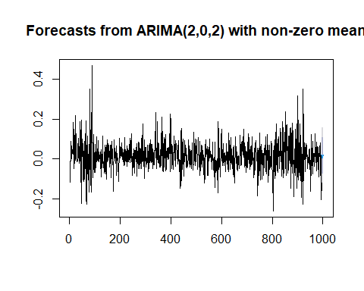
Forecast_m2 <- forecast(object = m2, h=5)
plot(Forecast_m2)
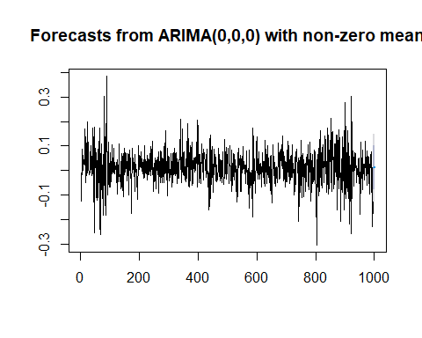
Forecast_m3 <- forecast(object = m3, h=5)
plot(Forecast_m3)
